

**SCSJ3253**

**PROGRAMMING TECHNIQUE III**

**REPORT FOR PROJECT**

Prepare for:

**PM DR MOHD SHAHIZAN OTHMAN**

|  |  |  |
| --- | --- | --- |
| 1 | NEOH SIEW TENG | SX180532CSJS04 |
| 2 | RAMLI ABDUL RAHIM | SX161518CSJF04 |
| 3 | ROHAYA BINTI ABDUL KARIM | SX180608CSJS04 |
| 4 | NOR AMIRA BINTI AHMAD AZIZI | SX160105CSJS04 |

Contents

1. Project Overview 1

1.1 Title 1

1.2 Objective 1

2. Tools, Technology & Languages Used 1

3. System Module 1

3.1 Hosts Countries List & Tournaments Module 1

3.2 Winners List Module 1

3.3 Top Goal Scorers List Module 1

4. Module Functionality 1

4.1 Home Page 1

4.2 Admin Login Page 2

4.3 User Page 2

5. Database Design 2

5.1 Entity Relationship Diagram 2

5.2 Use Case Diagram 2

5.3 Activity Diagram 2

6. References 2

## Project Overview

### Title

The title of our project is **“The Historical Track of FIFA World Cup”**. We believed that there is no glory without a story, and being the most prestigious football tournament in the world, FIFA World Cup has many stories to tell and worth to trace.

### Objective

Following the successful conclusion of 2022 FIFA Men's World Cup in Qatar, many are still flushed with the skills that Lionel Messi has performed in the final match against France. A month has over now but the news of the World Cup, Cristiano Ronaldo vs Lionel Messi still occupies the news leads.

During the tournament, we were updated by all the latest news and results of World Cup 2022, but for those who just started following or watching the World Cup, few know the history of FIFA World Cup, i.e., when was the inaugural world cup, which countries were the champion, runner up, third place in the particular tournament? etc. We reckoned that the history is worth to trace, and worth to know. Therefore, we would like to developed a “learning” system about FIFA World Cup, for old fans and beginners to learn about the history of FIFA World Cup since its inaugural.

## 2. Tools, Technology & Languages Used

## 3. System Module

There will be three modules in this system, namely the Hosts Countries List & Tournaments Module, Winners List Module and Top Goal Scorers List Module.

Users will get to view information as above mentioned selected by year, country or both on the user page. For admin page, the admin will manage relevant information from there.

### 3.1 Hosts Countries List & Tournaments Module

### 3.2 Winners List Module

### 3.3 Top Goal Scorers List Module

## 4. Module Functionality

### 4.1 Home Page

Home Page will be the first page that users and admins would see when they landed in this site.

### 4.2 Admin Login Page

### 4.3 User Page

## 5. Database Design

### 5.1 Entity Relationship Diagram

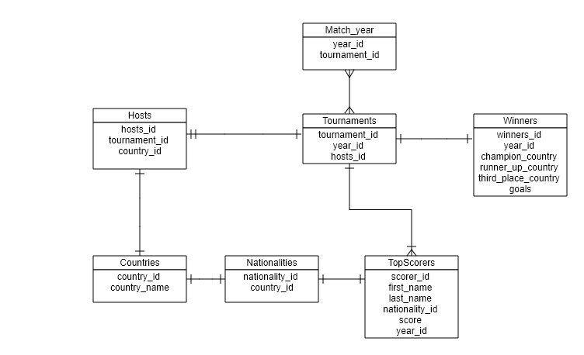

Figure 1.1: Database Diagram for “The Historical Track of FIFA World Cup”

The above database has 7 tables:

1. The Match_year table stores the data of year that has the FIFA tournament.

2. The Hosts table stores data about host country of each tournament.

3. The Tournaments table stores data about year of tournament and the host country.

4. The Winners table stores data of champion, runner up and third place of the tournaments and the

goals result.

5. The Countries table stores data of countries where the tournaments were hosts, winners and the

nationality of top scorers (which country they represented)

6. The Nationalities table stores the nationality data of the scorer (which country they belong to/

represent to play in the tournament)

7. The TopScorers table stores data of the players who score the most goals in a particular tournament

and their scores.

### 5.2 Use Case Diagram

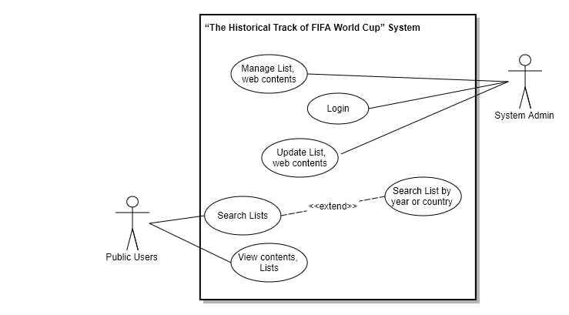

Figure 1.2: Use Case Diagram for “The Historical Track of FIFA World Cup”

### 5.3 Activity Diagram

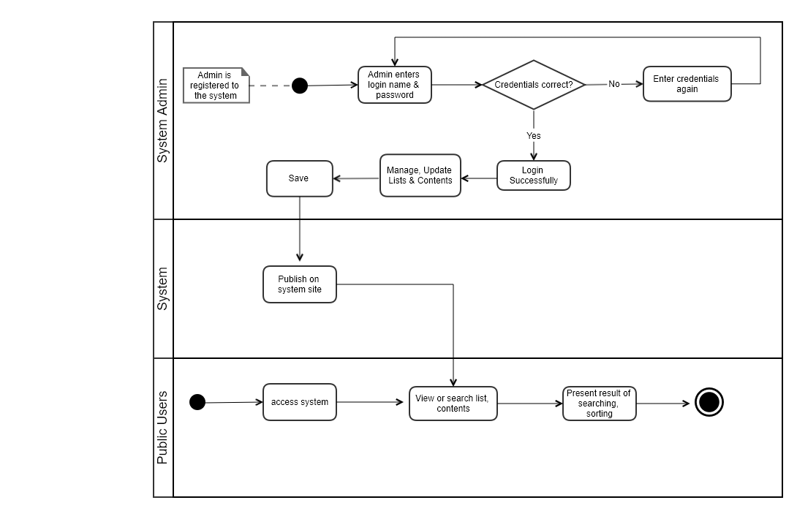

Figure 1.3: Activity Diagram for “The Historical Track of FIFA World Cup”

## 6. References

i) <https://www.foxsports.com/soccer/2022-fifa-world-cup/history>

ii) <https://www.footballhistory.org/world-cup/index.html>

iii) <https://en.wikipedia.org/wiki/FIFA_World_Cup_hosts>